**EXPERIMENT 2**

**USN: 1BM21CS231**

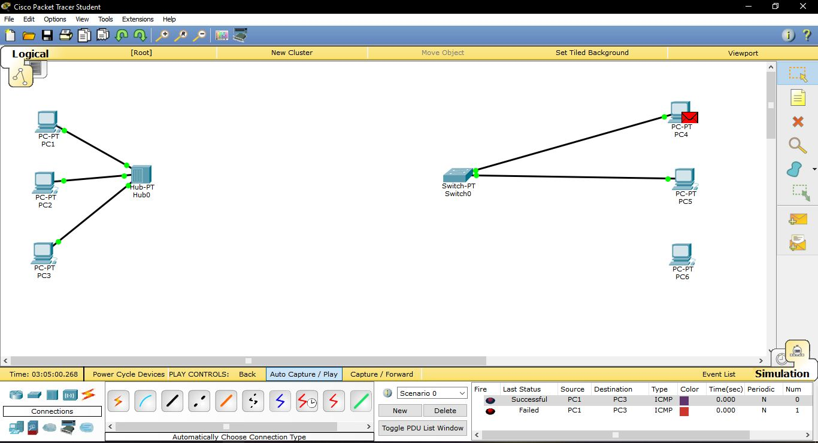

**SCENARIO 1: PACKET TRANSFER BETWEEN PCs OF HUB**

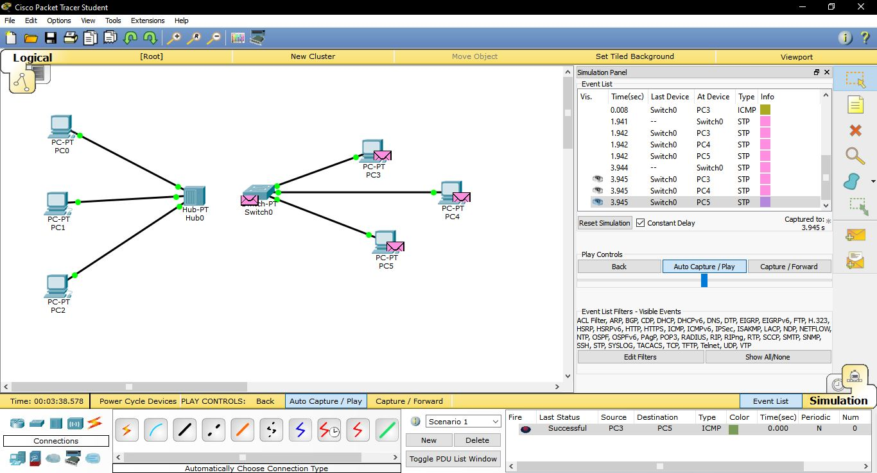

**SCENARIO 2: PACKET TRANSFER BETWEEN PCs OF SWITCH**

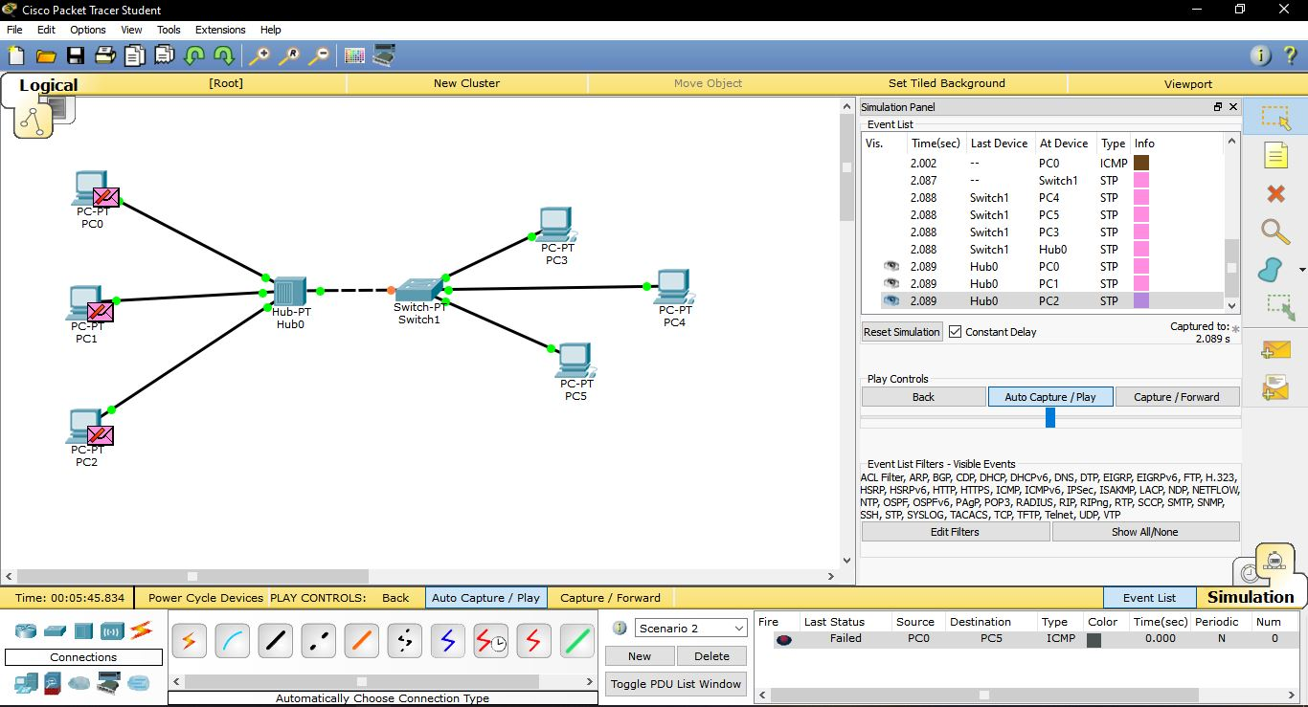

**SCENARIO 2: PACKET TRANSFER BETWEEN PCs OF HUB & SWITCH**

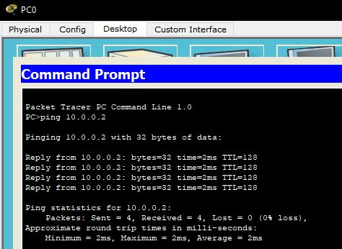





**PING COMMAND FOR ALL THE THREE SCENARIO WHEN THE IP ADDRESS IS CONFIGURED**



